**­CSC 1101 – Problem Solving and Programming Laboratory – Winter 2019**

**Lab 09 – (student name)**

**25 points – Due January 12, end-of-class**

**a)** Save this document with your name and the lab assignment number somewhere in the file name.

**b)** Type/paste your answers into the document.

c) Submit this document and your .cpp file(s) to the Canvas item where you downloaded this document. Do not submit a zip file but individually attach your files.

You are hired to design a wall color cost calculator. Red costs $5 per square foot, Blue costs $1 per square foot, and Green costs $3 per square foot. Make a copy of the C++ template for your applicationand make the following edits:

1) Rename the copy you made to **Lab07.cpp.**

2) Complete the header comment.

3) Declare four variables:

● *Color* (string), *Area* (int), *Price* (int), and *Total* (int).

4) Using **cin**, prompt the user for values and assign them to the *Area and Color* variables.

5) Using **if-elseif-else statements** assign the *Price* that matches the user’s chosen *Color*.

6) Calculate the *Total* based on the *Color, Price,* and the *Area* of the wall.

7) Modify the application header and close to contain the application name.

8) Run the program and show your results, output should look like this:

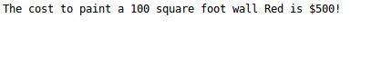

*[your program code here]\**

**//==========================================================**

**//**

**// Title: Wall Cost**

**// Course: CSC 1101**

**// Lab Number: Lab09**

**// Author: Trevor Trusty**

**// Date: 2/12/2019**

**// Description:**

**// Prompts user area of wall and a paint color, and displays the cost**

**// of the project.**

**//**

**//==========================================================**

**#include <conio.h> // For function getch()**

**#include <cstdlib> // For several general-purpose functions**

**#include <fstream> // For file handling**

**#include <iomanip> // For formatted output**

**#include <iostream> // For cin, cout, and system**

**#include <string> // For string data type**

**using namespace std; // So "std::cout" may be abbreviated to "cout"**

**int main()**

**{**

**//Declare Variables**

**int area, price, total;**

**string color;**

**char open = 'y';**

**const string myApp = "Wall Cost";**

**// Show application header**

**cout << "Welcome to " << myApp << " !" << endl;**

**cout << "--------------------------" << endl << endl;**

**while (open == 'y') //Keeps looping program until user opts out**

**{**

**//Prompt user for area, and color**

**cout << "Enter area of wall: ";**

**cin >> area;**

**cout << endl;**

**cout << "Enter desired color: ";**

**cin >> color;**

**cout << endl;**

**while (color != "red" && color != "blue" && color != "green")**

**{**

**cout << "Color must be Red, Blue, or Green" << endl;**

**cout << "Enter desired color: ";**

**cin >> color;**

**cout << endl;**

**}**

**//red = 5;**

**//double blue = 1;**

**//green = 3;**

**//Test for color to determine price**

**if (color == "red")**

**price = 5;**

**else if (color == "blue")**

**price = 1;**

**else if (color == "green")**

**price = 3;**

**//Calculate total cost**

**total = area * price;**

**//cout << "test: you typed " << color << " and it's price is " << price << " dollars." << endl;**

**cout << "The cost to paint a " << area << " square foot wall " << color << " is " << total << " dollars." << endl;**

**cout << "\nWould you like to find the cost of another wall? (y/n): ";**

**cin >> open;**

**cout << endl;**

**}**

**// Show application close**

**cout << "\nEnd of " << myApp << endl << endl;**

**// Pause before application window closes**

**cout << "Press any key to exit ..." << endl;**

**_getch();**

**}**

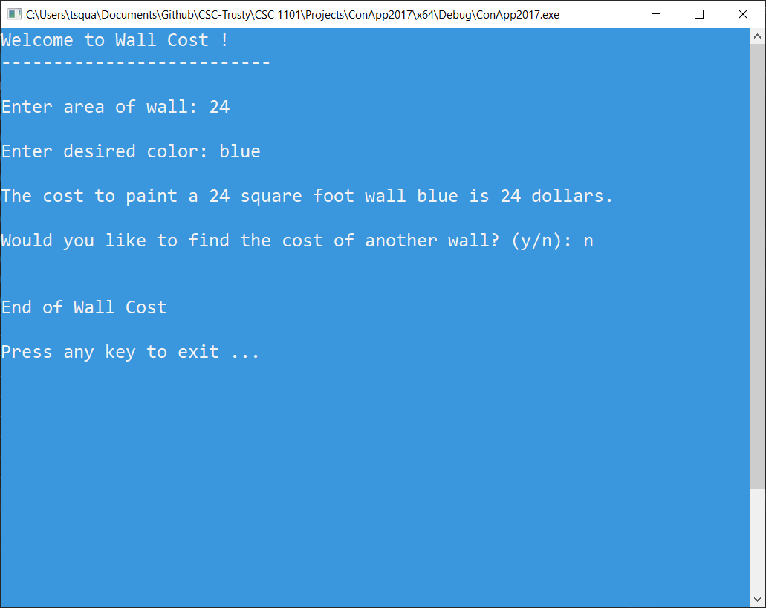

* **Copying-and-pasting Visual C++ code to a Word document**

1) From within the Visual C++ program, press **CTRL-A** and press **CTRL-C**.

2) From within the Word document, press **CTRL-V**.

** **Copying-and-pasting Visual C++ console application output to a Word document**

1) From the Visual C++ console, press **ALT-PrintScreen**.

2) From within the Word document, press **CTRL-V**.